1. **Mocking and Stubbing**

package com.example.mockdemo;

import org.junit.Test;

import static org.junit.Assert.*;

public class AssertionExamplesTest {

@Test

public void testBasicAssertions() {

assertEquals("Values should match", 10, 5 + 5);

assertTrue("Number should be greater than 0", 7 > 0);

assertFalse("Number should NOT be negative", -1 > 0);

String name = "MockTest";

assertNotNull("Name should not be null", name);

String empty = null;

assertNull("Empty should be null", empty);

    }

}

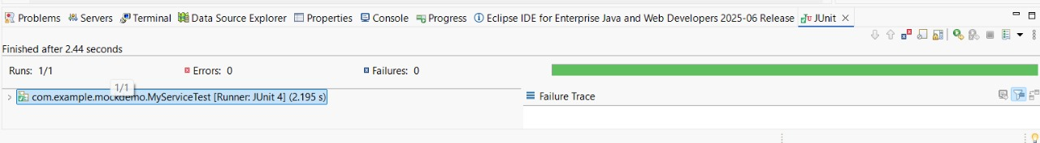

1. **Verifying Interactions**

package com.example.mockdemo;

import org.junit.Test;

import static org.junit.Assert.*;

public class AssertionExamplesTest {

@Test

public void testBasicAssertions() {

assertEquals("Values should match", 10, 5 + 5);

assertTrue("Number should be greater than 0", 7 > 0);

assertFalse("Number should NOT be negative", -1 > 0);

String name = "MockTest";

assertNotNull("Name should not be null", name);

String empty = null;

assertNull("Empty should be null", empty);

}

}

